Business Requirements Document (BRD)

Library Management Portal
Dept. of Technology, Pune University.

Project ID: DOT/LMP/PRJ/2025

Version: 1.0

Document No.: DOT/LMP/PRJ/2025/1.0

Date: 01/01/2025

Author: Abhishek A. Kininge

2.0 Table of Contents

Sr. No. | Name | Page No.
1 | Project Details
2 | Table of Contents
3 | Document Control
4 | Business Objectives & Purpose
5 | Stakeholder Analysis
5.1 | Approvals
5.2 | RACI Matrix
6 | Scope of Work
6.1 | In Scope
6.2 | Out of Scope
7 | Business Process
7.1 | Current Process (AS-IS)
7.2 | Future Process (TO-BE)
8 | Requirements
9 | Assumptions
10 | Constraints
11 | Limitations (Optional)
12 | Risks
13 | Dependencies
14 | Appendices
15 | Glossary of Terms
16 | Related Documents / References

3.0 Document Control

Date | Version No. | Document Changes
01/01/0225 | 1.0 | Initial Draft

4.0 Business Objectives & Purposes:

a. Objective / Purpose

- Digitally transforming the Department of Technology’s (DoT) library book exchange system from a manual, offline process to an online, streamlined solution.
- Making online Library Management Portal (LMP) for students, staff, librarian & admin.
- Enable students & staff to:
  - Register & create library membership by paying the fee online.
  - Login & manage account passwords.
  - View dashboard to search, sort, filter & reserve books online, view and pay fines incurred online & to request new books online.
- Enable library staff to:
  - Login & manage account passwords.
  - View dashboard to search, sort, filter & reserve books online, check fines outstanding online & to check new books requests and also view student details online.
  - To check daily book transaction.
  - To manage book inventory online.
  - Generate payment receipts online.
- Enable admin to:
  - Login & manage account passwords.
  - View dashboard to search, sort, filter & reserve books online, check fines outstanding online & to check new books requests and also view student details online.
  - Manage all student & staff credentials in the system.
  - View/generate reports related to Books usage, Fine generation & new book requests.

b. Business Value

- The portal will simplify library operations for both students and staff by digitizing multiple offline tasks.
- It will minimize manual errors and eliminate the need for redundant offline file storage.
- Library staff will benefit from streamlined workflows and a centralized dashboard providing a real-time snapshot of key activities such as book tracking, fine management, and new book requests.
- Students will be able to monitor fines and due dates, promoting timely book returns and a more disciplined exchange system.

c. Background Info

The Department of Technology (DoT) Library currently operates using manual registers and physical membership cards for managing its book inventory, user records, and transactions.

Condition Leading to Initiation
The reliance on offline systems has led to inefficiencies such as delayed book exchanges, manual errors in fine calculations, overlooked book requests, and operational strain during peak membership periods. These challenges highlighted the urgent need for a digital transformation of the library system.

Problem Areas
It leads to manual errors while writing book/student/staff names, dates, payment amounts etc. leading to inefficient operations and reworks and results in members’ gradiences.

Current Challenges:
- The manual process of collecting library membership registration fees is time-consuming, and the sudden surge in membership requests at the beginning of each academic year places excessive strain on staff, disrupting daily library operations.
- Errors in fine calculation and management often lead to student dissatisfaction.
- Delays in book returns hinder many students’ academic progress, as others are unable to access essential books on time.
- Tracking overdue or lost books is labor-intensive and inefficient.
- Multiple new book requests are often overlooked due to the lack of a centralized tracking system.

Business Rules:
- Student Membership Registration:
Every new student must register by paying a mandatory, non-refundable membership fee of ₹200, after which they will be issued a library membership card.
- Mandatory Membership Card:
Possession of a valid library membership card is required for students to access any library services.
- Eligibility for Library Services:
Library services are exclusively available to students and staff of the Department of Technology, Pune University.

- Student Borrowing Duration:
Students are allowed to borrow a book for a maximum period of 14 days.
- Overdue Fine for Students:
If a book is not returned by the due date, a fine of ₹5 per day will be charged for up to 90 days.
- Lost Book Penalty – Students:
If a book is not returned within 90 days of the due date, it will be deemed “Lost”, and the student must pay a penalty equivalent to the current market value of the book plus ₹500.
- Penalty for Lost or Damaged Books – Students:
In case of loss or damage to a book, the student must pay the market value of the book plus ₹500.
- Student Borrowing Limit:
A student may borrow only one book at a time.
- Book Renewal Restriction – Students:
Books borrowed by students cannot be renewed. Students must return the book and re-borrow it, subject to availability.
- Staff Borrowing Limit:
Staff members are allowed to borrow up to five books simultaneously.
- Staff Borrowing Duration:
Staff may borrow a book for a maximum period of 90 days.
- Fine Exemption – Staff:
Staff members are exempt from overdue fines, except in cases of book loss or damage.
- Penalty for Lost or Damaged Books – Staff:
In the event of book loss or damage, staff are subject to the same penalty as students: Market value of the book plus ₹500.

5.0 Stakeholder Analysis

5.1 Approvals

Role | Name | Title | Signature | Date
Project Sponsor | Dr. Devi Prasad | Head of Department
Business Owner | Baburao Ganpatrao Apte | Librarian / SME
Project Manager | Mr. Raju | Project Manager
System Architect | Mr. Shyam | System Architect
Team Lead | Mr. Kabira | Team Lead
Business Analyst | Mr. Abhishek AK | Business Analyst
Quality Lead | Khadak Singh | Quality Lead

5.2 RACI Chart

* | Authorize | Has ultimate signing authority for any changes to the document.
R | Responsible | Responsible for creating this document.
A | Accountable | Accountable for accuracy of this document (for example, the project manager)
C | Consulted | Provides input (such as an interviewee).
I | Informed | Must be informed of any changes.

Activity | PM | BA | Dev | DBA | TL | Sy. Arch. | QA / Tester | Client / SME
BRD |  | RA |  |  |  |  |  | *
Coding |  |  | R |  |  | A
Database |  |  |  | RA
System Architecture |  |  |  |  |  | RA |  | C
Testing | C | C |  |  | R |  | RA | I
UAT | C | C |  |  |  |  | C | RA / *
Deployment | RA |  | R | C | R | C | I | I
Training |  | RA |  |  |  |  | C | C

5.3 User Roles:

Role | Description | Key Permissions / Actions
Student | Registered user who can access library services for borrowing books | - Register, login, reset password - Search, reserve, borrow, return, and renew books - View dashboard, book status, due dates, fines - Make online fine payments - Request new books - Receive notifications via Email/SMS
Staff | University teaching or non-teaching staff eligible for extended borrowing rights | - Login, reset password - Search, reserve, borrow (up to 5 books), return books - View dashboard and book status - Request new books - Receive notifications - Exempt from fines unless book is lost/damaged
Librarian | Library personnel responsible for managing daily library operations | - Login, reset password - Search/manage books and users - Add/edit/remove books, authors, subjects - Manage borrowing, returns, fines, memberships - Generate receipts - Receive alerts for book requests
Admin | System administrator managing overall access and configurations | - Login, reset password - Manage user credentials for students and staff - Search/view all records - Generate reports (book usage, fines, requests) - Monitor platform activity

6. Scope of Work

6.1 In Scope
- Student:
  - Registration
  - Login
  - Search books
  - Sort & Filter
  - View
    - Dashboard / Homepage
    - My Books Status
    - Return Dates
    - Fines Calculation
    - Fines Payment
  - Reserve a book
  - Renew a book
  - Request a new book
  - Notifications on Email & SMS
    - Requested book available
    - Reserved book available
    - Reminder for books submission
    - Delayed submission notification
- Librarian:
  - Login
  - Search books
  - Sort & Filter books
  - Search students
  - View
    - Dashboard / Homepage
    - Books Status
    - Return Dates
  - Books Inventory
    - Add / Edit / Remove Books
    - Add / Edit / Remove Authors
    - Add / Edit / Remove Subject
  - Fines Management
    - View Fines Related Details
    - Fines Payment
    - Fines payment receipt generation
    - Membership fees payment receipt generation
  - Notifications on Email & SMS
    - New Requested books
  - Book exchange
    - Returned book status update
    - Issued book status update
- Admin:
  - Login
  - Search books
  - Sort & Filter books
  - Search students
  - View
    - Dashboard / Homepage
    - Books usage report
    - Fine generation report
    - New book requests report
  - Credential Management
Add / Edit / Delete Student & Staff credentials

Feature Group | Student | Librarian | Admin
User Access | Registration, Login | Login | Login
Search & Browse | Search, Sort & Filter Books | Search Books, Sort & Filter Books, Search Students | Search Books, Sort & Filter Books, Search Students
Dashboards & Views | - Dashboard/Homepage  - My Books Status  - Return Dates | - Dashboard/Homepage  - Books Status  - Return Dates | - Dashboard/Homepage- Books Usage Report- Fine Generation Report- New Book Requests Report
Book Management | - Reserve a Book- Renew a Book- Request a New Book | - Inventory: Add/Edit/Remove Books, Authors, Subjects- Book Exchange (Returned/Issued status update) | —
Fines & Payments | - Fine Calculation- Fine Payment | - View Fines- Accept Payment- Generate Receipts (Fines, Membership Fees) | - Fine Generation Report
Notifications | - Requested Book Available- Reserved Book Available- Submission Reminder- Delayed Submission Alert | - New Requested Books | —
Credential Management | — | — | Add/Edit/Delete Student & Staff Credentials

6.2 Out of Scope

- Integration with University’s Student Portal.
- Books database migration & update.
- Mobile app development (this project only covers browser-based web portal).
- Advanced analytics or AI powered features.
- Logins for members other than students, librarians, staff & admins.
- Book recommendations.
- Integration with University’s payments system.

7. Business Process

7.1 Current Process (AS-IS)
Current manual process of borrowing & returning the books.
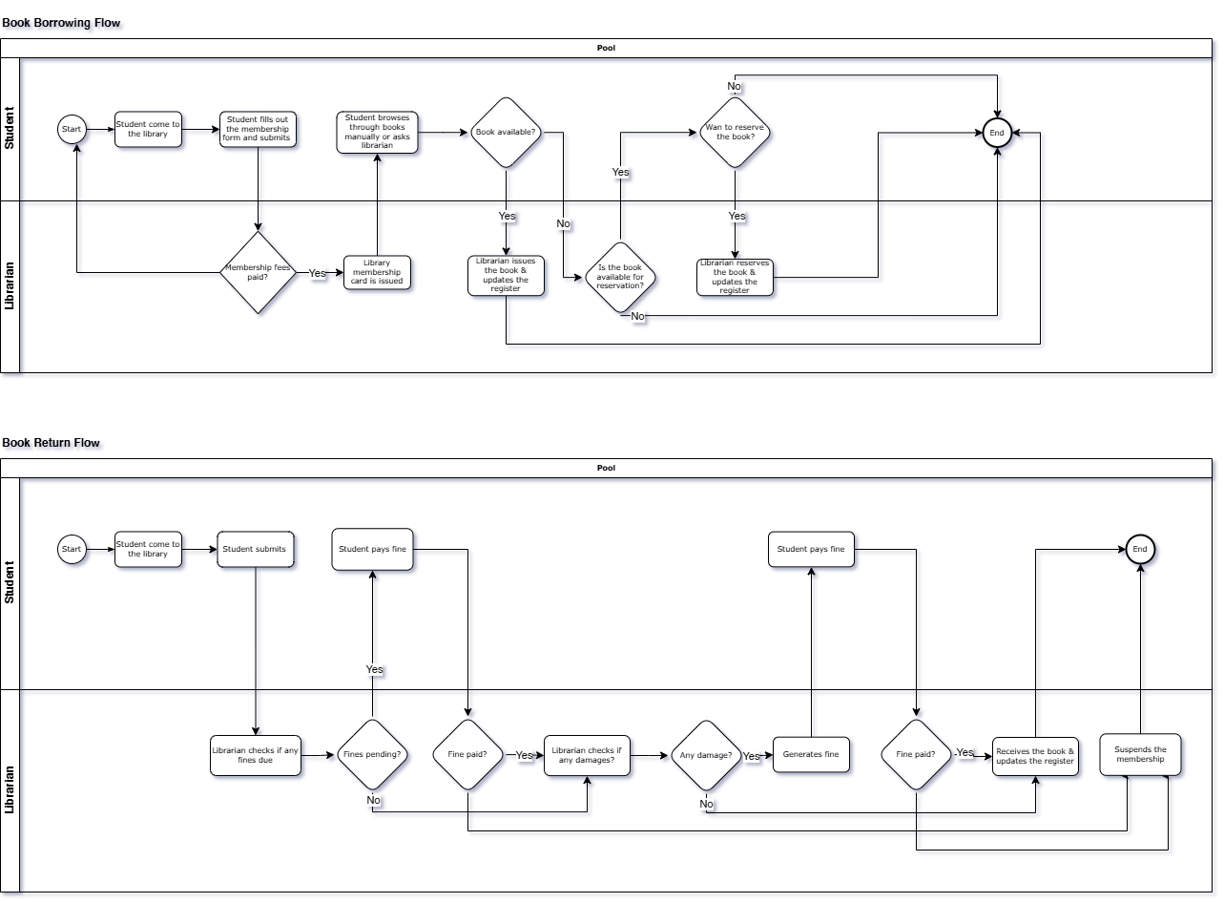

7.2 Future Process (TO-BE)
Description of the Future State.
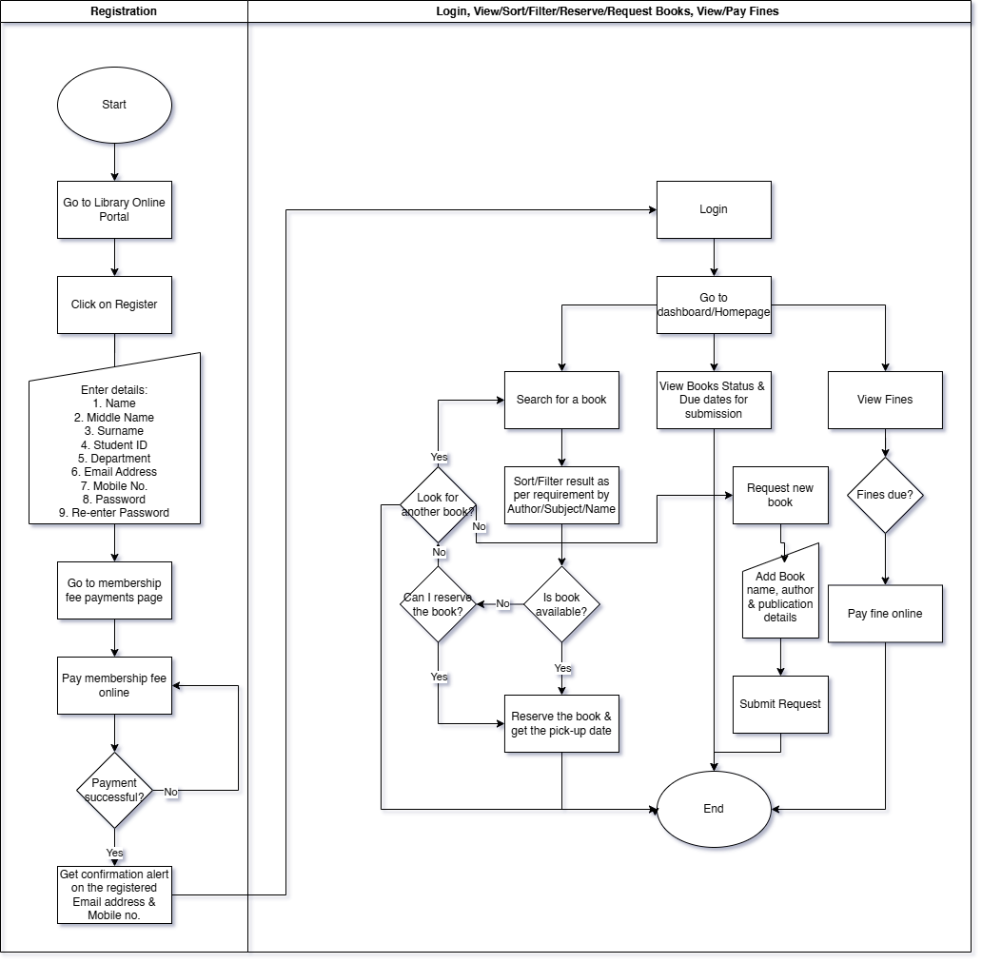

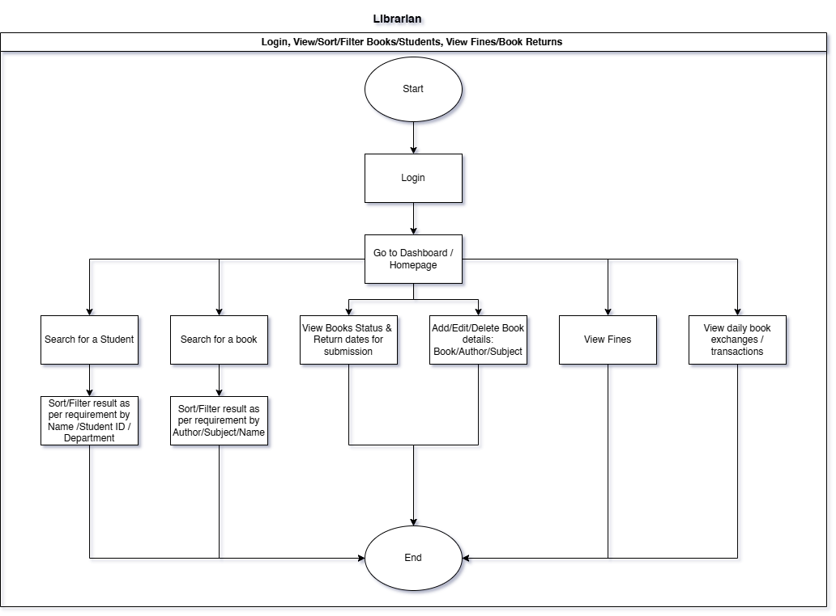

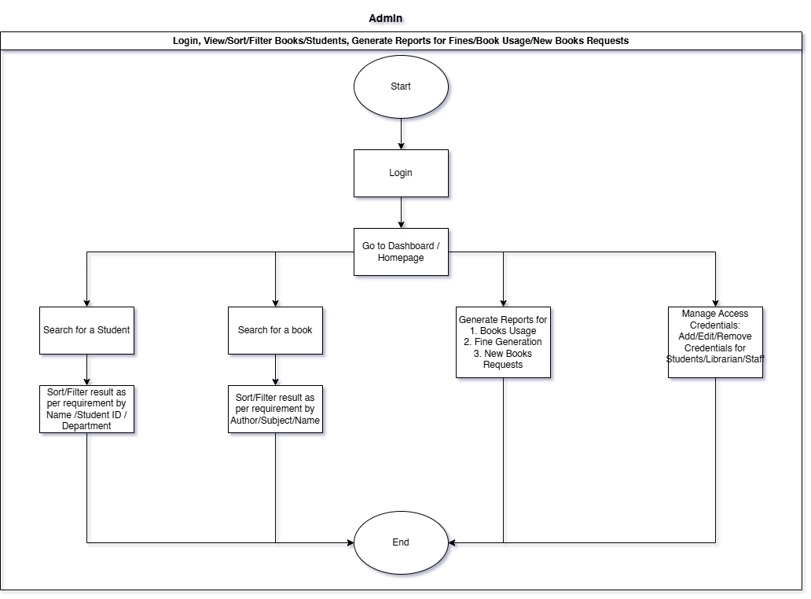

8. Requirements

8.1 Business Requirements

- Ability for the student to:
  - Register as a new user
  - Login in to the LMP
  - Reset/Change Forgot Password
  - Search desired books
  - Sort & Filter, the search results by Name, Subject, Author & Publisher
  - View
    - Dashboard / Homepage
    - My Books Status like Borrowed/Due, Overdue, Reserved etc.
    - Return Dates of the borrowed books
    - Fines Calculation of the overdue books
  - Make online payment for fines incurred
  - Reserve a book so that it can be borrowed
  - Renew a book that is already borrowed.
  - Request a new book that is currently not available in the library/has limited copies available.
  - Enable Notifications on Email & SMS for students to receive when:
    - A requested book available
    - A reserved book available
    - A book is due for submission in next 2/1/0 days.
    - A book return due date is missed

- Ability for the Librarian to:
  - Login in to the LMP
  - Reset/Change Forgot Password
  - Search desired books
  - Sort & Filter, the search results by Name, Subject, Author & Publisher
  - Search students
  - Sort & Filter, the search results by Name, Student ID & Department
  - View
    - Dashboard / Homepage
    - Books Status like total books due for return, Returns due today
    - Return Dates and Returns due today
  - Manage the Books Inventory by
    - Adding / Editing / Removing Books
    - Adding / Editing / Removing Authors
    - Adding / Editing / Removing Subject
  - Manage & Membership Fees Payments by:
    - Viewing details related to Fines generated
    - Viewing Fines Payments
    - Generating fines payment receipt
    - Generating membership fees payment receipt
  - Receive Notifications on Email & SMS for librarians when:
    - New books requests are generated
  - To view daily book exchange by
    - Returned book status update
    - Issued book status update

- Ability for the Admin to:
  - Login in to the LMP
  - Reset/Change Forgot Password
  - Search desired books
  - Sort & Filter, the search results by Name, Subject, Author & Publisher
  - Search students
  - Sort & Filter, the search results by Name, Student ID & Department
  - View Dashboard / Homepage
  - Generate reports like
    - Books usage report
    - Fine generation report
    - New book requests report
  - Manage User Access Credential by
Adding / Editing / Removing Student & Staff credentials/user login

8.1 Functional Requirements
- Xxx
- Xxx
- Xxx

8.2 Non-Functional Requirements
- System uptime 99%
- System should work smoothly with simultaneous logins from all students of the department (approx. 2000 pax).
- System should be scalable so that more students can be enrolled as new courses are introduced.

8.3 Requirements Traceability Matrix (RTM) *(Not applicable in Agile Scrum)

Sample Project: Online Flight Booking Application
Business Requirements Document  BRD |  | Functional Specification Document  FSD |  |  | Test Case Document
Business Requirement ID# | Business Requirement / Business Use case | Functional Requirement ID# | Functional Requirement / Use Case | Priority | Test Case ID# | Execution Status | Defect#
BR_1 | Reservation Module | FR_1 | One Way Ticket booking | High | TC#001  TC#002 | pass
 |  | FR_2 | Round Way Ticket | Low | TC#003  TC#004 | pass
 |  | FR_3 | Multicity Ticket booking | High | TC#005  TC#006 | Fail | Defect# 4523
BR_2 | Payment Module | FR_4 | By Credit Card | High | TC#007  TC#008 | pass
 |  | FR_5 | By Debit Card | High | TC#009 | pass
 |  | FR_6 | By Reward Points | Medium | TC#010  TC#011 | pass

9. Assumptions
- Books Data Digitization:
Librarians & the department staff will be converted all the books inventory data in a prescribed digital format.
- Project will cater to the Department of Technology, Pune University only and the LMP will have no interface with the University / other departments.
- User Access:
All students, librarians, and admins will have access to the internet and can use the portal via a web browser or mobile application.
- Availability of Data:
The library will maintain an updated and accurate inventory of books, and student/member information will be readily available for the system to manage.
- Payment Gateway Availability:
Online payment systems (such as credit/debit cards, UPI, etc.) will be available and functioning for students to pay fines and membership fees.
- User Skill Level:
Students, librarians, and admins have basic technical skills to use the system (such as using a browser, entering text, and navigating websites).
- Library Database:
The library’s database will be regularly updated to reflect book availability, borrower information, fines, and reservations.
- Library Hours: The system assumes the library is open during standard hours, and that the operation of borrowing and returning books will follow the library’s working hours.

10. Constraints
- Budget Constraints:
The project must be developed within a predefined budget that may limit the features, technologies, or resources available for implementation.
- Time Constraints:
The project must be completed within a specific time frame (e.g., within 6 months), potentially limiting the scope of features or the complexity of the system.
- Access Control: The system will follow a role-based access control (RBAC) model, where different user roles (students, staff, librarians, admins) have different levels of access. This can constrain the flexibility of features and user interfaces.
- Book Availability: The system can only show books that are currently available in the library’s catalog; if physical copies are unavailable or out of stock, the system cannot proceed with reservations.
- Payment Processing: The system is constrained by the availability and security of third-party payment gateways, and may not be able to accept all payment methods.
- User Device Compatibility: The system might be limited to web-based access or a specific mobile platform, depending on the device compatibility and user preferences.
- Internet Dependency: The portal assumes that users have a stable internet connection, limiting access in areas with poor internet connectivity.

11. Limitations (Optional)
- No Offline Functionality:
The portal cannot provide offline access to students or librarians for book management or reservation if there’s no internet connection.
- Limited Notification Channels:
Notifications are only sent via email and SMS; the system does not support other methods like push notifications or in-app messaging.
- Limited Reporting:
The admin might be able to generate basic reports (book usage, fines, etc.), but advanced analytics or AI features might not be included in the initial system version.
- No Integration with External University Systems:
The library system might not integrate with other university systems (e.g., student information systems, University’s main library etc.) unless explicitly developed for future stages.

12. Risks
- Technical Risks:
  - System Downtime/Server Issues:
The portal could experience downtime or slow performance due to server issues, affecting user access and experience.
  - Data Loss or Corruption:
If proper backup systems are not in place, there is a risk of data loss or corruption (e.g., student details, book inventory, payment history) which could affect the portal’s functionality.
- Operational Risks:
  - User Adoption:
Students, librarians, and admins may struggle to use the system effectively due to unfamiliarity with the interface or lack of proper training, resulting in low adoption rates.
  - Poor Data Entry:
If data such as book information, student details, or payment records are entered incorrectly, it could affect the functionality and accuracy of the system (e.g., wrong fines calculated, wrong books assigned).

13. Dependencies
- Availability of a user authentication system (login, password reset, role-based access).
- Integration with SMS gateway for mobile notifications.
- Integration with Email service for email alerts.
- Integration with a payment gateway for online fine and membership fee transactions.
- Library data digitization & migration from existing/legacy library inventory system.
- Availability of accurate & up-to-date library/University/business/regulatory rules and policies for fine calculation, borrowing limits, etc.
- Availability of Stakeholders and Subject Matter Experts (SMEs) (e.g., librarians, staff, admis, and student representatives) for accurate requirements gathering, validation of business rules, feedback during UAT (User Acceptance Testing), and overall decision-making throughout the project lifecycle.

14. Appendices
Supporting content (e.g., survey results, wireframes, flowcharts)

15. Glossary of Terms

Sr. No. | Term | Definition
1 | BRD | Business Requirement Document
2 | UAT | User Acceptance Testing
3 | LMP | Library Management Portal
4 | BR | Business Requirement
5 | FR | Functional Requirement
6 | NFR | Non-Functional Requirement
7 | DoT | Department of Technology

16. Related Documents
- DoT website:
http://www.unipune.ac.in/dot/
- Governors State University: Library Management System
"Library Management System" by Katyaini Manne

